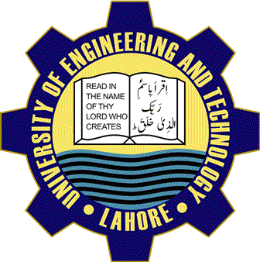
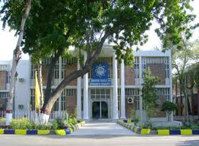
DEPARTMENT OF COMPUTER SCIENCE AND ENGINEERING
UET LHR

- Visit Us Online  Uet.acm@gmail.com  lms.uet.edu.pk  Cse.uet.edu.pk |  | 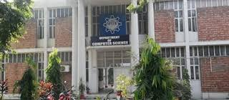
T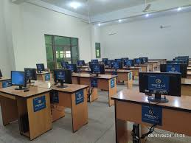 | Internationally recognized  - UET Graduates are eligible to work globally. it is associated Washington Accord Programs offered in Computer Science.

COURSE OFFERED
- BSC Computer Science
- BSC Computer Engineering
- MSC Computer Science
- MSC Computer Engineering
CAREERS
- Software Development
- Network & Computer System
- Computer Network & Architects

TECHNICAL SOCIETY
UET ACM is one of the celebrated
Scientific society which is actively
Participated in different events in
Collaboration with ICOSST (KICS)
- IEE UET Society
- COMPUTER CLUB
- IET SOCIETY
COMPUTER FACULITIES Computer cell is providing complete facilities with internet with advance internet service to whole universities
Dean: Prof. Dr. Suhail Aftab Qurashi
Chairman: Prof. Dr. Muhammad Shahbaz

CONTACT US
UET Admission: 042-99029216
Registrar: 042-99029227
Deputy Registrar: 042-99029209
Assistant Registrar: 042-99029417
THE SCIENCE OF TODAY IS THE TECHNOLOGY OF TOMORROW
Edward Teller

